# 🚀 AWS Infrastructure Deployment with Terraform

This project demonstrates how to use **Terraform** to deploy a basic AWS infrastructure that includes:

* A **Virtual Private Cloud (VPC)**
* A **Public Subnet** with **Internet Gateway**
* An **EC2 Instance**
* An **S3 Bucket**

## 📁 Project Structure

aws-infra/  
├── main.tf # Main Terraform configuration  
├── variables.tf # Input variables  
├── outputs.tf # Output values  
├── README.md # Project documentation

## 📸 Architecture Diagram

## 🔧 Prerequisites

* AWS Account with configured credentials (aws configure)
* Terraform installed on your system
* A pre-created AWS EC2 Key Pair (used for SSH access)

## 📦 Resources Created

1. **VPC**: A custom VPC with CIDR 10.0.0.0/16
2. **Subnet**: Public subnet in ap-south-1a
3. **Internet Gateway**: Attached to the VPC
4. **Route Table**: Routes internet traffic from the subnet
5. **Security Group**: Allows inbound SSH (port 22)
6. **EC2 Instance**: Amazon Linux 2, t2.micro
7. **S3 Bucket**: Unique globally-named bucket

## ⚙️ How to Deploy

### 1. Clone the Repo

git clone https://github.com/your-repo/aws-infra.git  
cd aws-infra

### 2. Initialize Terraform

terraform init

### 3. Apply Configuration

terraform apply -var="key_name=your-key" -var="bucket_name=your-unique-bucket-name"

Confirm with yes when prompted.

### 4. Output

* Public IP of the EC2 instance
* S3 bucket name

## 📤 To Destroy the Infrastructure

terraform destroy -var="key_name=your-key" -var="bucket_name=your-unique-bucket-name"

## 📚 Notes

* Make sure the S3 bucket name is **globally unique**.
* Replace your-key with your **actual EC2 Key Pair** name.
* This project uses **Mumbai region (ap-south-1)** by default. You can change it in main.tf.

## 📸 Screenshots

### Terraform Apply Example

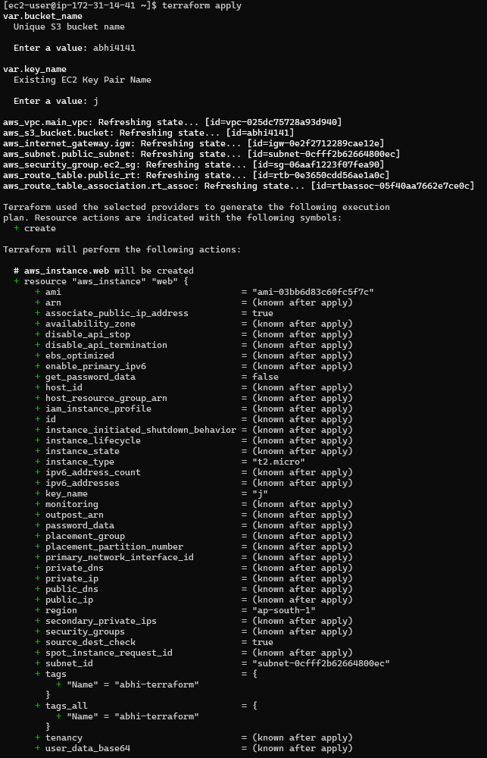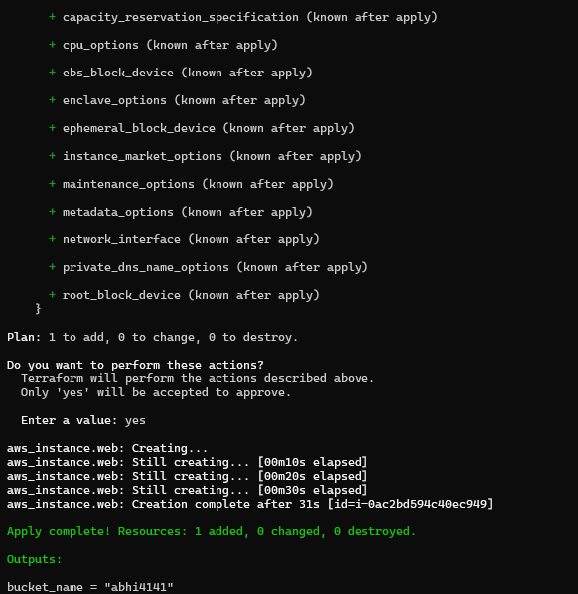

### AWS Console Verification

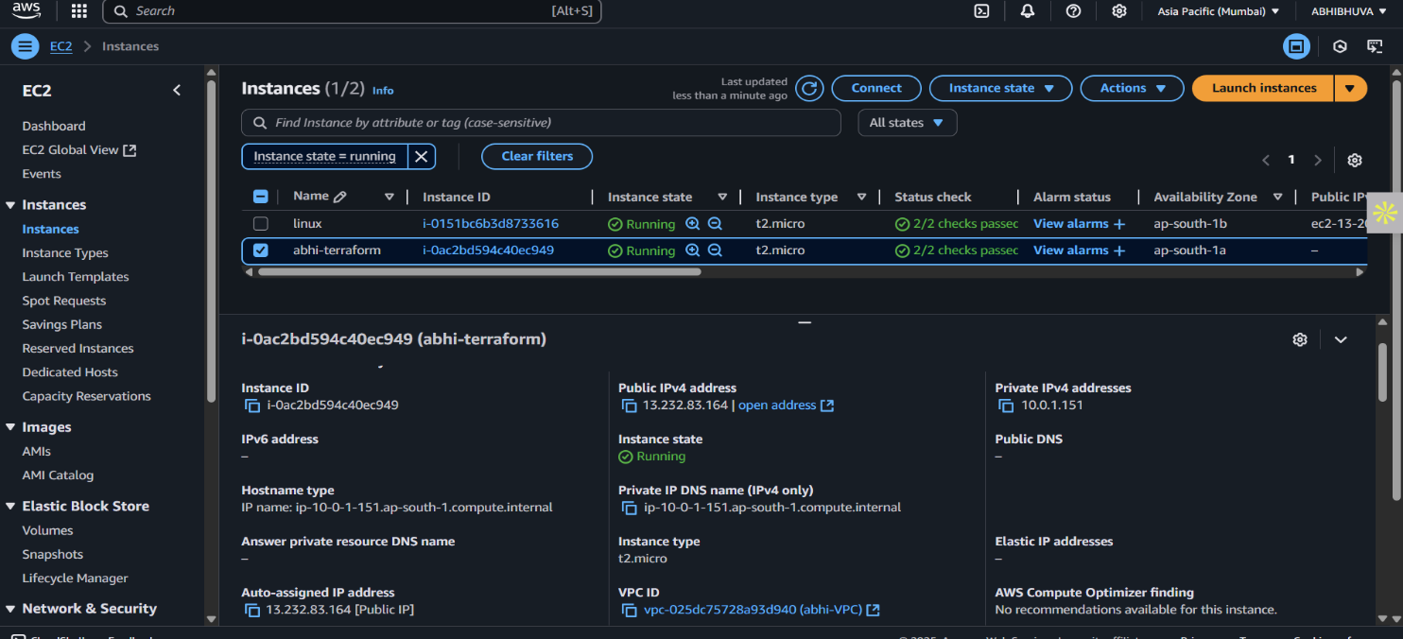

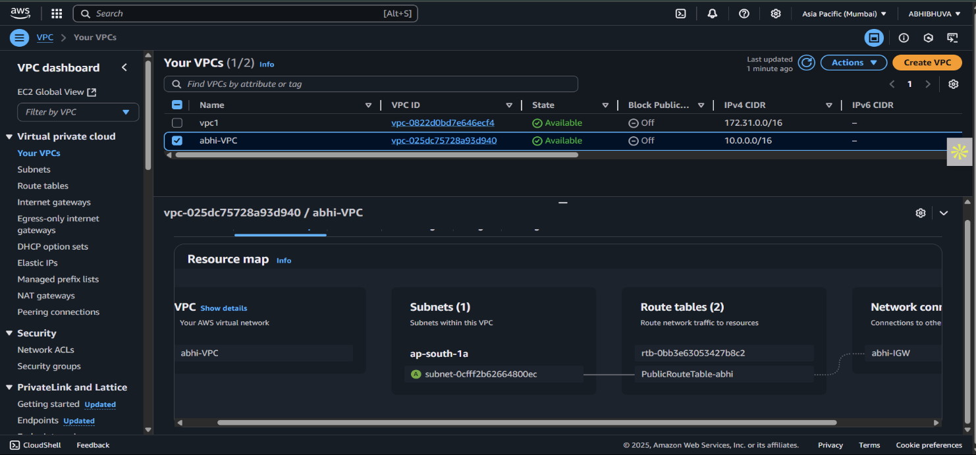

## 🧠 Author

**Abhi Bhuva**  
DevOps Engineer

Feel free to customize this setup to fit more complex architectures (e.g., private subnets, RDS, ALB, auto scaling, etc.).